**WHAT IS DATABASE IN SQL?**

SQL database is a dataset that uses SQL language. It consists of tables with rows and columns containing data and a unique primary key. Such databases can establish links — or relationships — between the data by joining tables. That's why they are also referred to as relational databases.

**1.TABLES: -**

The database contains 4 tables customers, orders, products and order_item

**2. COLUMNS: -**

For each table, list the columns with their data types, descriptions, constraints and if they are primary or foreign keys.

**Table 1: - Customers**

Columns Data type Description

Customer_id integer unique customer identifier

Customer_name varchar (100) Name of customers

Email varchar (100) email of customers

Phone_number integer Number of customers

PRIMARY KEY = customer_id

**Table 2: - Orders**

Columns Data type Description

Order_id varchar (15) unique order_id identifier

Customer_name varchar (50) Name of customers

Product varchar (50) Name of product

Quantity integer count of products

Price decimal (10,5) price of product

Order_date Date date of the order product

Customer_id integer Reference

PRIMARY KEY = order_id

FOREIGN KEY = customer_id

**Table 3: - Products**

Columns Data type Description

Product_id varchar (15) unique product identifier

Product_name varchar (50) name of the product

Category varchar (50) category of the product

Price decimal (10,5) price of the product

Stock_quantity integer products available

Rating decimal (10,5) rating of the product

Order_id varchar (15) Reference

PRIMARY KEY = Product_id

FOREIGN KEY = order_id

**Table 4: - order_item**

Columns Data type Description

Order_id Integer unique order id

Product_id varchar (15) unique product identifier

Quantity integer count of products

Price_per_unit decimal (10,5) price of the product

Total_price decimal (10,5) total price of product

Order_date Date date of the order product

**DATA BASE RELATIONSHIP**

1. Customer to orders relationship
2. Orders to product relationship
3. Products to order_item relationship

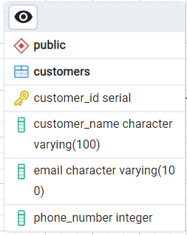**ER DIAGRAM**

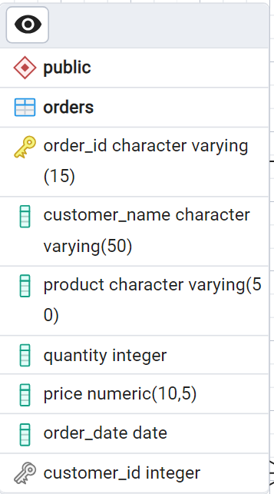

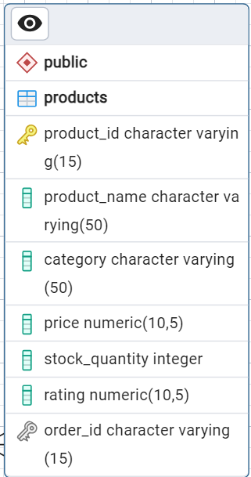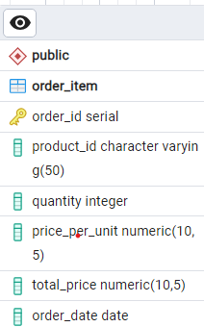

**Database query: Full join**

select c.customer_name,c.email,c.phone_number,o.order_id,o.product,o.quantity,o.price,o.order_date,p.product_id,p.product_name,

p.category,p.price,p.stock_quantity,p.rating,a.order_id, a.price_per_unit,a.total_price,a.order_date

from customers as c

full join orders as o

on c.customer_id = o.customer_id

full join products as p

on o.order_id=p.order_id

full join order_item as a

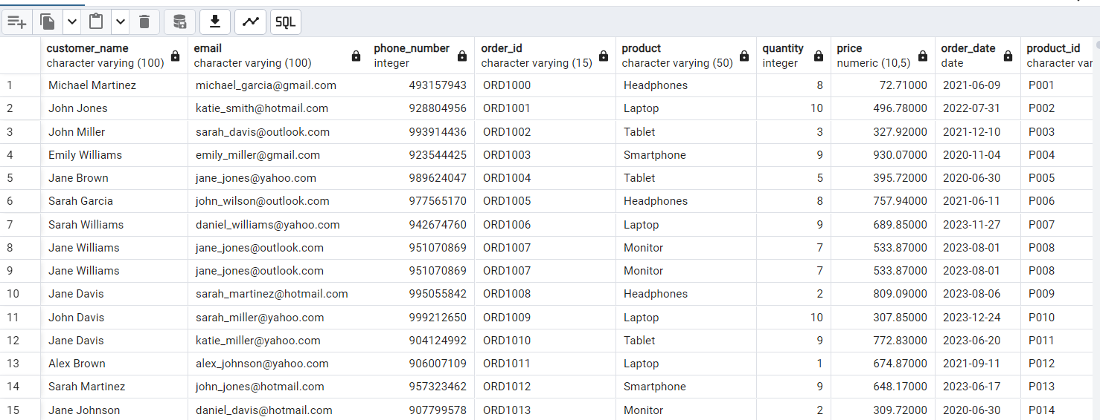on p.product_id=a.product_id